COMPUTER PROJECT
CLASS 12

Software name-
“PARAMAK Mall Sales-cum-Database Management Software”

By – Gaurang Dixit
Class – XII Sc A
Roll Number – ___________

INDEX
Serial No. | Topic | Page No.
 | Project Introduction | 3
 | System Requirements | 4
 | Pre-requisites | 5
 | Modules Used and Functions Used | 6
 | Salient Features | 7
 | Implementation (Code) | 8-34
 | Output | 35-39
 | Acknowledgement | 40
 | Certificate | 41

PROJECT INTRODUCTION

This software was designed for the computer science project of class XII (CBSE). This software is meant to be used at the billing counters at a mall or any other retail store and also by the head or admin of that place to get an overall view of the sales and to perform some important functions.
This is a software which is a multi-purpose which serves as an efficient billing system and at the same time creates a database of the same for further applications.

SYSTEM REQUIREMENTS

Recommended System Requirements
- Processors:Intel® Core™ i5 processor 4300M at 2.60 GHz or 2.59 GHz (1 socket, 2 cores, 2 threads per core), 8 GB of DRAMIntel® Xeon® processor E5-2698 v3 at 2.30 GHz (2 sockets, 16 cores each, 1 thread per core), 64 GB of DRAMIntel® Xeon Phi™ processor 7210 at 1.30 GHz (1 socket, 64 cores, 4 threads per core), 32 GB of DRAM, 16 GB of MCDRAM (flat mode enabled)
- Disk space: 2 to 3 GB
- Operating systems: Windows® 10, macOS*, and Linux*
Minimum System Requirements
- Processors: Intel Atom® processor or Intel® Core™ i3 processor
- Disk space: 1 GB
- Operating systems: Windows* 7 or later, macOS, and Linux
- Python* versions: 2.7.X, 3.6.X

Pre-requisites
Pre-requisites
A csv file named “customers” with the fields ‘id’, ‘name’, ‘number’ and ‘email’ in the cells A1, A2, A3 and A4 respectively. It will be stored in the same folder as the program file.

Note- Currently available usernames and passwords (these can be altered as per the customer’s requirement) are-
1. sales1@abcmall.com (password= sales1)
2. sales2@abcmall.com (password= sales2)
3. sales3@abcmall.com (password= sales3)
4. admin@abcmall.com(password=admin123)

Modules Used and Functions Used

Modules Used
- csv- Used to perform read and write operations on a csv file which stores customer details.
- pickle- Used to perform read and write operations on a binary file which contains data regarding the items bought by a customer.

Functions Used
- csv_reader()- Used to open and read the data of the ‘customers.csv’ file which stores details of all customers. It returns the number of customers in the file, the list of all keys and the last key of the list.
- bin_reader()- Used to open and read the details of the binary files which store details of the items bought by a customer. It returns a list of all records in the binary file.

Salient Features

- Password protected.
- An extensive admin menu.
- Uses a binary file to store a great part of data. Hence the processing speeds are very high and file sizes are low.
- Option to modify or edit the records of a customer in admin menu.
- Program can work even if ‘items.bin’ file is not created.
- Unique feature to edit bills after entering the whole bill.
- All choices for the main menus are taken as strings. So even if someone enters an invalid option program will not crash and keep on running.
- Additional important checks like check for overwriting an item already in the bill, extensive checking of phone number, etc.

Implementation (Code)

#usernames allowed-
#1. sales1@abcmall.com (password= sales1)
#2. sales2@abcmall.com (password= sales2)
#3. sales3@abcmall.com (password= sales3)

#admin-
#username= admin@abcmall.com
#password= admin123

#-------------------------------------------------------------------------#

#Variables section

usernames={'sales1@abcmall.com':'sales1','sales2@abcmall.com':'sales2','sales3@abcmall.com':'sales3'}
admin_username={'admin@abcmall.com':'admin123'}
wish=True

#--------------------------------------------------------------------------#

#Importing modules

import csv
import pickle
#-------------------------------------------------------------------#

# Functions

def csv_reader():

f=open('customers.csv','r')
reader=csv.DictReader(f)
count=0
key_list=[]

for i in reader:
key=int(i['id'])
key_list.append(key)
count+=1

if (count==0): #for checking if the file is empty or not
last_key=100

else:
last_key=key
pass

f.close()

return count,key_list,last_key

def bin_reader(b):

g=open(b,'rb')
reader2=[]

try:
while True:
a=pickle.load(g)
reader2.append(a)
except:
g.close()

return reader2

#-----------------------------------------------------------------------#

#Main Program

print("**--------PARAMAK Mall Sales-cum-Database Management Software--------**")
print('\n \n',end='')

while wish:

#login part starts--------------------------------------------
print("*----------------------Main Menu----------------------*")
print("Enter 1 to login for salesperson section.")
print("Enter 2 to login for admin section.")
print("Enter 3 to exit.")
print('\n',end='')
choice=input("Enter your choice:")

if (choice=='1' or choice=='2' ):

for i in range(0,3): #Username part
username=input("Enter your username(Max. 3 tries):")

if ((username in usernames and choice=='1') or (username in admin_username and choice=='2')):
break

else:
print("Wrong username!")
continue

else: #this part will execute only if loop ends normally or all tries are over

print('\n',end='')
print("Your tries are over.")
ask=input("Do you want to again continue the main program(y/n)?")

if(ask in ['y','Y','yes']):
wish=True
print('\n',end='')
continue
else:
wish=False
print("Exiting....")
break

for i in range(0,3): #password part

print('\n',end='')
password=input("Enter your password(Max. 3 tries):")

if (choice=='1' and (username in usernames) and password==usernames[username]):
break

elif (choice=='2' and (password==admin_username['admin@abcmall.com']) and username=='admin@abcmall.com'):
break

else:
print("Wrong password!")
continue

else: #this part will execute only if loop ends normally or all tries are over

print('\n',end='')
print("Your tries are over.")
ask=input("Do you want to again continue the main program(y/n)?")

if(ask in ['y','Y','yes']):
wish=True
print('\n',end='')
continue
else:
wish=False
print("Exiting....")
break

elif(choice=='3'):
print("Exiting....")
print('-------------------------------*------------------------------------')
break

else:
print('\n',end='')
print("You have entered wrong option.")

print('\n',end='')
ask=input("Do you want to again continue the main program(y/n)?")

if(ask in ['y','Y','yes']):
wish=True
print('\n',end='')
continue
else:
wish=False
print("Exiting....")
break

#login part over---------------------------------------#

#salesperson section-----------------------------------#

if(username in usernames):

print('\n',end='')
print('-------------------------------*------------------------------------')
print("Welcome Salesperson.")

#checking for last key so as to continue from there
#also making a list of all keys

count_key,key_list,key=csv_reader()

#last key checking over

f=open('customers.csv','a+')
writer=csv.DictWriter(f,fieldnames=['id','name','number','email'],lineterminator='\n')

ask_new=input("Enter customer id(if any) or else enter 0:")

if(ask_new.isdigit()):

ask_new=int(ask_new)

if(ask_new==0):

key=key+1

print('\n',end='')
name=input("Enter name:")

for i in range(0,3):
number=input("Enter contact number(Max. 3 tries):")

if(number.isdigit() and len(number)==10):
break
else:
print("Invalid number!")
continue

else: #this part will execute only if loop ends normally or all tries are over

print('\n',end='')
print("Your tries are over.")
print('\n',end='')
ask=input("Do you want to again continue the main program(y/n)?")

if(ask in ['y','Y','yes']):
wish=True
continue
else:
wish=False
break

email=input("Enter email id:")

writer.writerow({'id':key,'name':name,'number':number,'email':email})

f.close()

elif( ask_new in key_list):

key=ask_new
print("Key is valid.Moving to billing section.")

else:
print('\n',end='')
print("Entered id is not valid.")

print('\n',end='')
ask=input("Do you want to again continue the main program(y/n)?")

if(ask in ['y','Y','yes']):
wish=True
continue
else:
wish=False
break

else:
print('\n',end='')
print("Invalid input")

print('\n',end='')
ask=input("Do you want to again continue the main program(y/n)?")

if(ask in ['y','Y','yes']):
wish=True
continue
else:
wish=False
break

#customer details section over-----------

#customer items section start---------------------------

f=open("items.bin",'ab')
cart=True #for items adding
item={}
price=[] #list containing quantity,cost per piece and total price per product
print('\n')
print('-------------------------------*------------------------------------')
print("Billing starts.")

while cart:

print('\n',end='')
product=input("Enter product name:")
cost=float(input("Enter product price (per item or per (kg or L)):"))
quantity=float(input("Enter number of pieces (or kg or L):"))
print('\n')

#checking for cost=0----------------

if (cost<=0):
print("Product price cannot be less than or equal to 0. Try again....")
print('\n',end='')
continue

# checking over-------------

# checking for same product given again--------------

if (product in item):
print("This item is already listed once.")
print("If you continue this new value will overwrite the previous one.")
print('\n',end='')
ask_product=input("Do you want to continue(y/n):")
print('\n',end='')

if (ask_product in ['y','Y','yes']):
pass
else:
print("Reiterating....")
print('\n',end='')
continue

#checking over--------------------

price=[quantity,cost,(quantity*cost)]

item[product]=price

print('\n',end='')
ask_item=input("Do you want to add 1 more item(y/n)?")

if(ask_item=='y'):
cart=True
continue
else:
cart=False
break

#correcting records if entered wrong------------------
wish_correction=True

print('\n',end='')
ask_correction=input("Do you wish to delete or modify any item(y/n)?")

while wish_correction:

if (ask_correction in ['y','Y','yes'] and len(item)!=0):
print('\n',end='')
print("Enter 1 to modify a product.")
print("Enter 2 to delete a product.")
print("Enter 3 to exit.")

choice_correction=input("Enter your choice:")
print('\n',end='')

if (choice_correction=='1'):
item_name=input("Enter product name:")

for i in item:
if (i==item_name):
print('\n',end='')
product=input("Enter new product name:")
cost=float(input("Enter product price (per item or per (kg or L)):"))
quantity=float(input("Enter number of pieces (or Kg or L):"))
print('\n',end='')

#checking for cost=0----------------

if (cost<=0):
print("Product price cannot be less than or equal to 0. Try again....")
print('\n',end='')
break

# checking over-------------

del item[i] #storing return value of pop function

# checking for same product given again--------------

if (product in item):
print("This item is already listed once.")
print("If you continue this new value will overwrite the previous one.")
print('\n',end='')
ask_product=input("Do you want to continue(y/n):")
print('\n',end='')

if (ask_product in ['y','Y','yes']):
pass
else:
print("Reiterating....")
print('\n',end='')
break

#checking over--------------------

price=[quantity,cost,(quantity*cost)]
item[product]=price
print("Updation successful.")
break
else:
print('\n',end='')
print("Product not found.")

elif (choice_correction=='2'):
item_name=input("Enter product name:")

for i in item:
if (i==item_name):
del item[i]
print("Deletion successful.")
break
else:
print('\n',end='')
print("Product not found.")

elif (choice_correction=='3'):
print("Exiting menu....")
break

else:
print('\n',end='')
print("Invalid option.")

print('\n',end='')
ask_again=input("Do you wish to again continue this menu(y/n)?")

if (ask_again in ['y','Y','yes']):
wish_correction=True
continue
else:
break

elif (len(item)==0):
print('Cart is empty. Exiting menu....')
break

else:
break

#records correction over-----------------------------------
amt=0

for i in item:

amt=amt+item[i][2]

sales=username

#Checking if no item is bought------------

if (len(item)==0):
item='No product bought.'

#checking for empty item dictionary---------------

dict1={'id':key,'item':item,'amt':amt,'sales':sales}
pickle.dump(dict1,f)

#printing of bill
print('\n')
print('\-/-\-/-\-/-\-/-\-/-\-/-\-/-\-/-\-/-\-/-\-/-\-/-\-/-\-/-\-/-\-/-\-/-\-/')
print("Customer ID is-",key)
print('\n',end='')
print("The bill is as follows:")
print('\n')

if (item=='No product bought.'): #checking if no item bought
print(item)
print('\n',end='')

else:
for i in item:
print("Product-",i,"; Quantity-",item[i][0])
print("Cost/piece- Rs",item[i][1],"; Total cost- Rs",item[i][2])
print('\n',end='')

print("Total bill amount is:- Rs",amt)
print('\n')

print("THANKS FOR SHOPPING WITH US!!")
print("HAVE A NICE DAY.... :-) ")
print('\-/-\-/-\-/-\-/-\-/-\-/-\-/-\-/-\-/-\-/-\-/-\-/-\-/-\-/-\-/-\-/-\-/-\-/')
print('\n')
print('-------------------------------*------------------------------------')

f.close()

#bill part over
#salesperson part over

#admin part starts

elif(username in admin_username):

wish2=True

while wish2:
print('\n')
print('-------------------------------*------------------------------------')
print("Welcome Admin!")

print("Enter 1 to see customer details.")
print("Enter 2 to see items bought by a customer.")
print("Enter 3 to see the sales amount and number of orders per salesperson.")
print("Enter 4 to see total revenue.")
print("Enter 5 to see average money spent by a customer.")
print("Enter 6 to see the total number of orders.")
print("Enter 7 to see the total number of customers.")
print("Enter 8 to modify or delete customer details.")
print("Enter 9 to see the billings made by a salesperson.")
print("Enter 10 to exit.")

print('\n',end='')
choice_admin=input("Enter your choice:")
print('\n',end='')

#making a list of all keys

count_key,key_list,last_key=csv_reader()

#key checking over and pointer goes to the end
#so we close and open the file again

#opening customers file
f=open('customers.csv','r')
reader=csv.DictReader(f)
#opening over

#opening items file and storing all values in reader2
try: # using 'try' to check if item file is there or not
b="items.bin"
reader2=bin_reader(b)
except:

if(choice_admin=='10'): # exiting if user gives exit command
print('\n',end='')
print("Exiting menu.")
print('-------------------------------*------------------------------------')
break
else:
print("No data available.")
print("Reiterating menu.")
continue

#opening and storing over for items file

if(count_key==0):
if (choice_admin=='10'):
print('\n',end='')
print("Exiting menu.")
print('-------------------------------*------------------------------------')
break
else:
print("FILES ARE EMPTY.")

elif(choice_admin=='1'):

print("Enter 1 to view details of a customer.")
print("Enter 2 to view details of all customers.")
print("Enter 3 to exit.")

print('\n',end='')
choice_details=input("Enter your choice:")
print('\n',end='')

if(choice_details=='1'):

key=int(input("Enter customer key:"))

if(key in key_list):

print('\n',end='')
print("The customer details are as follows:-")

for i in reader:

if(int(i['id'])==key):

print('Name-',i['name'],'; Id-',i['id'])
print('number-',i['number'],'; Email-',i['email'])
print('\n',end='')

else:
print('\n',end='')
print("Entered key doesn't exist in database.")

elif(choice_details=='2'):

for i in reader:

print('Name-',i['name'],'; Id-',i['id'])
print('number-',i['number'],'; Email-',i['email'])
print('\n',end='')

elif (choice_details=='3'):
print("Exiting menu.")
pass

else:
print("You have entered a wrong operator.")

elif(choice_admin=='2'):

key=int(input("Enter customer key:"))

if(key in key_list):

count_orders=1 #counts the numbers of orders made by the person

for i in reader2:

if (i['id']==key):

print('\n',end='')
print('\n',end='')
print("This is order number-",count_orders)
print('\n',end='')
print("The billing was done by:",i['sales'])
print('\n',end='')
print("The items are as follows:")
print('\n')
dic=i['item']

if (dic=='No product bought.'):
print(dic)
print('\n',end='')

else:
for j in dic:
print("Product name-",j,'; Quantity-',dic[j][0])
print("Cost/piece- Rs",dic[j][1],'; Total cost- Rs',dic[j][2])
print('\n',end='')

print("Total bill amount- Rs",i['amt'])
count_orders+=1

else:
print('\n',end='')
print("Entered key is not in database.")

elif(choice_admin=='3'):

dic={} #temporary dictionary for storing salesperson's number of order and revenue

for i in reader2:

b=i['sales']
count2=0
amount=0

if (b not in dic):
for j in reader2:
if (j['sales']==b and j['amt']!=0): #checking if customer bought something or not
count2+=1
amount+=j['amt']

dic[b]=[count2,amount] #storing info in a dic with list values

for k in dic:
print('Salespersons is -',k)
print(" Total number of orders are:",dic[k][0])
print(" Total sales amount is:",dic[k][1])
print('\n',end='')

elif(choice_admin=='4'):

revenue=0

for i in reader2:

revenue+=i['amt']

print("The total revenue is- Rs",revenue)

elif(choice_admin=='5'):

revenue=0 #first finding total revenue

for i in reader2:

revenue+=i['amt']

#finding total number of orders
orders=0
for j in reader2:
orders+=1

average=revenue/orders

print("The average spend per customer is: Rs",average)

elif(choice_admin=='6'):

orders=0
for i in reader2:

if (i['amt']!=0): #checking for customers who bought nothing
orders+=1

print("Total number of orders till now are:",orders)

elif(choice_admin=='7'):

customers_number=0

for i in reader:
customers_number+=1

print("Total number of customers till now are:",customers_number)

elif(choice_admin=='8'):

print('\n')
key=int(input("Enter key of the customer that need to be modified:"))

if (key in key_list):

print('\n',end='')
print("Enter 1 to change name.")
print("Enter 2 to change phone number.")
print("Enter 3 to change email address.")
print("Enter 4 to delete customer records.")
print("Enter 5 to exit.")

print('\n',end='')
choice_modify=input("Enter your choice:")
master_list=[] # list for storing all records to be inserted into the csv file
marker=0 #for telling if file was updated or not
h=open('customers2.csv','w')
writer=csv.DictWriter(h,fieldnames=['id','name','number','email'],lineterminator='\n')
writer.writeheader()
count=0 # for checking if all tries are over or not in number updation
print('\n')

if (choice_modify=='1'):
name=input("Enter new name:")

for i in reader:

if (int(i['id'])==key):
record=i # this is a dictionary that we receive from the csv file
record['name']=name # changing name in record
master_list.append(record)
else:
master_list.append(i)

writer.writerows(master_list) # writing all the records into the csv file
print("Name updated successfully.")
h.close()

elif (choice_modify=='2'):

for i in range(0,3): # inputing new number
number=input("Enter new contact number(Max. 3 tries):")

if(number.isdigit() and len(number)==10):
break
else:
print("Invalid number!")
count=count+1
continue

if (count==3): # skipping rest part if all tries over and going to the end
pass
else:
for i in reader:

if (int(i['id'])==key):
record=i # this is a dictionary that we receive from the csv file
record['number']=number # changing name in record
master_list.append(record)
else:
master_list.append(i)

writer.writerows(master_list) # writing all the records into the csv file
print("Number updated successfully.")
h.close()

elif (choice_modify=='3'):
email=input("Enter new email address:")

for i in reader:

if (int(i['id'])==key):
record=i # this is a dictionary that we receive from the csv file
record['email']=email # changing name in record
master_list.append(record)
else:
master_list.append(i)

writer.writerows(master_list) # writing all the records into the csv file
print("Email updated successfully.")
h.close()

elif (choice_modify=='4'):
for i in reader: #for deletion of record in csv file
if (int(i['id'])==key):
pass
else:
master_list.append(i)

writer.writerows(master_list)
h.close()

marker=2 #for deletion of record in binary file

elif (choice_modify=='5'):
marker=1
pass

else:
print("Invalid input.")
h.close()
marker=1

if ((marker==0 or marker==2) and count!=3): # copying data from customers2 only if updation took place
h=open('customers2.csv','r') # opening file again so that pointer starts from the bginning
p=open('customers.csv','w')
writer2=csv.DictWriter(p,fieldnames=['id','name','number','email'],lineterminator='\n')
writer2.writeheader()

reader3=csv.DictReader(h)

for j in reader3: # transferring records
writer2.writerow(j)

p.close()
h.close()

if (marker==2): #for deletion of records purposes

q=open('items2.bin','wb')

for k in reader2:
if (k['id']==key):
pass
else:
pickle.dump(k,q)

q.close() #closing file because pointer is at the end

q=open('items2.bin','rb') #opening file again to read
reader3=bin_reader('items2.bin')

r=open('items.bin','wb')

for m in reader3:
pickle.dump(m,r)

print("Deletion successful.")

r.close()
q.close()

else:
print("Invalid key.")

elif (choice_admin=='9'):

person=input("Enter username of salesperson:")

if (person in usernames):

count_orders=1

for i in reader2:
if (i['sales']==person):

print('\n',end='')
print('\n',end='')
print("This is billing number-",count_orders)
print('\n',end='')
print("The billing was done for customer with ID:",i['id'])
print('\n',end='')
print("The items are as follows:")
print('\n')
dic=i['item']

if (dic=='No product bought.'):
print(dic)
print('\n',end='')

else:
for j in dic:
print("Product name-",j,'; Quantity-',dic[j][0])
print("Cost/piece- Rs",dic[j][1],'; Total cost- Rs',dic[j][2])
print('\n',end='')

print("Total bill amount- Rs",i['amt'])
count_orders+=1

else:
print("Invalid username.")
print('\n',end='')

elif (choice_admin=='10'):
print("Exiting...")
break

else:

print("You entered an invalid option!")

#Closing all files at the end

f.close()

#asking if u want to use this menu again
print('\n \n',end='')
ask_admin=input("Do you wish to continue this menu(y/n)?")

if(ask_admin=='y'):
wish2=True
continue
else:
wish2=False
print("Exiting....")
print('-------------------------------*------------------------------------')
break

print('\n \n',end='')
ask=input("Do you want to continue the main program again(y/n)?")

if(ask in ['y','Y','yes']):
wish=True
print('\n',end='')
else:
wish=False
print("Exiting....")
print('-------------------------------*------------------------------------')
brea
Output

I. Salesperson section
- Starting Menu-
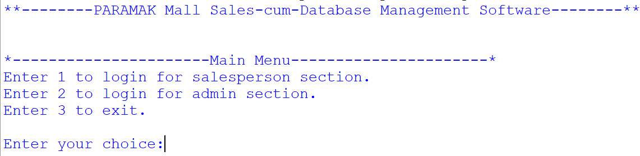

- Login and new customer section-

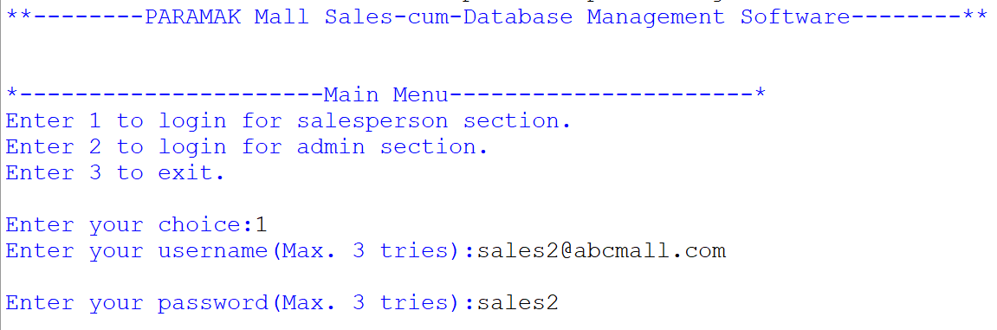
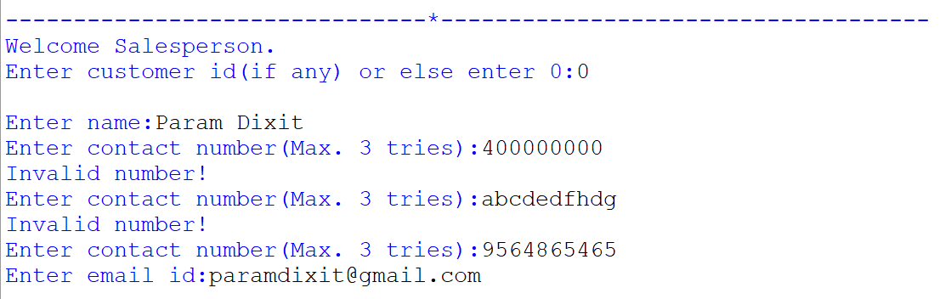

- Billing section
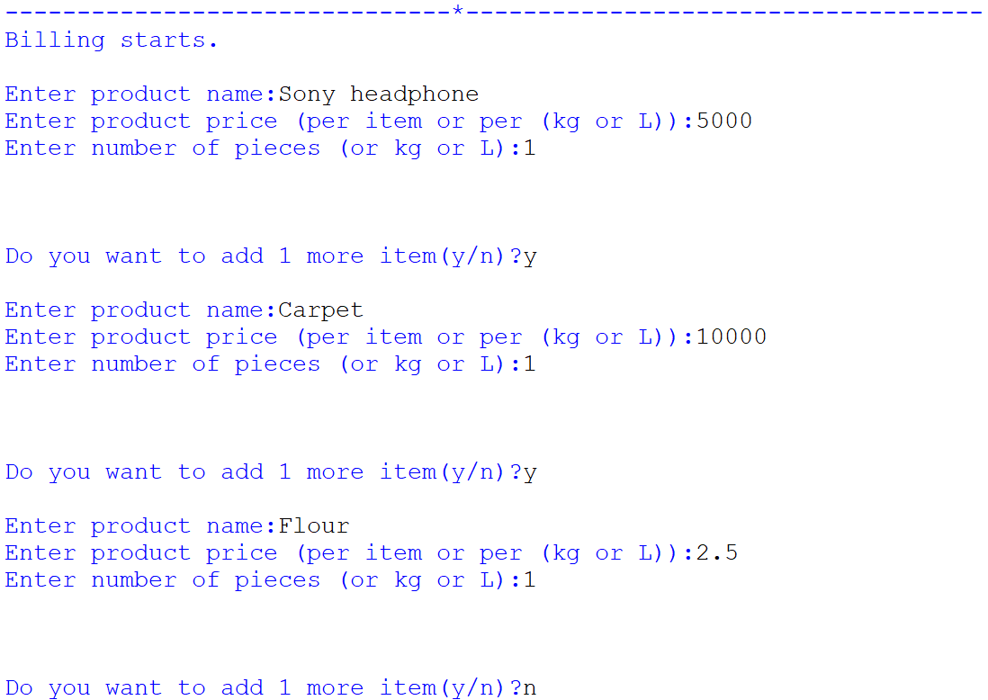
- Bill modifying menu
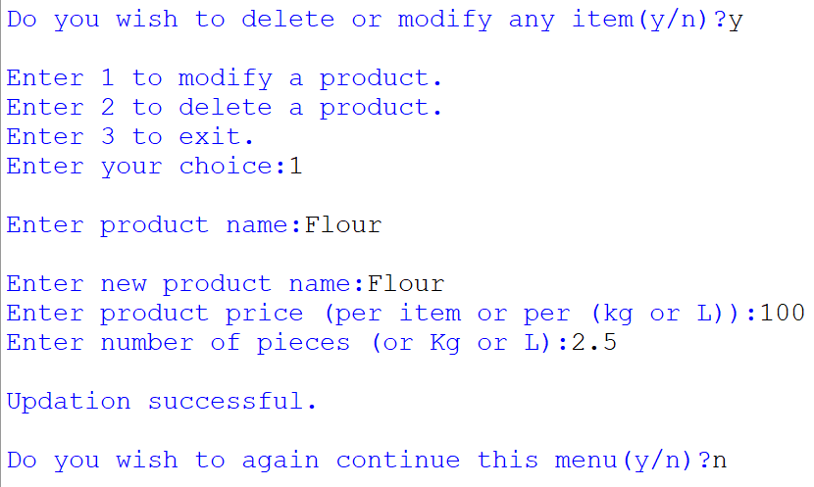
- Bill printing menu
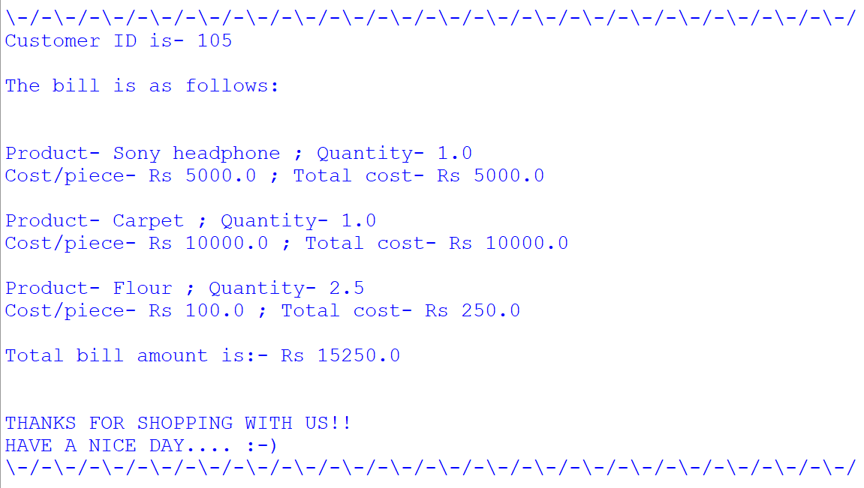

II. Admin menu

- Login and menu
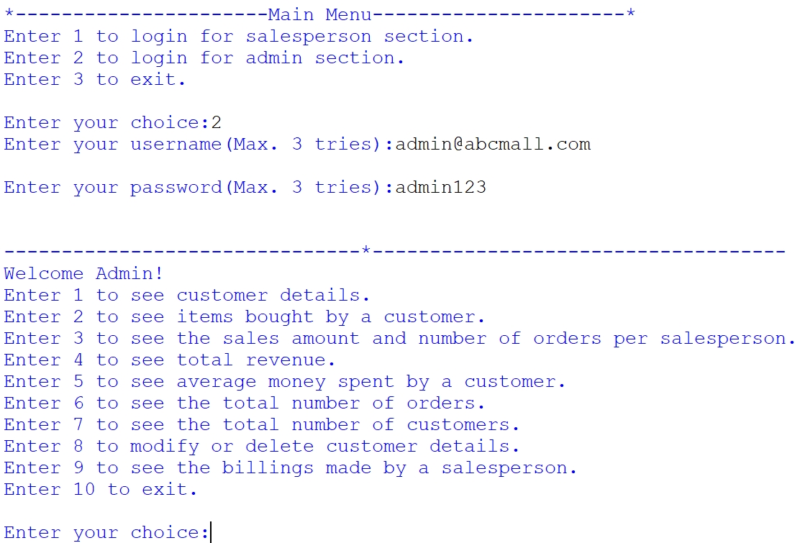

- 1st option
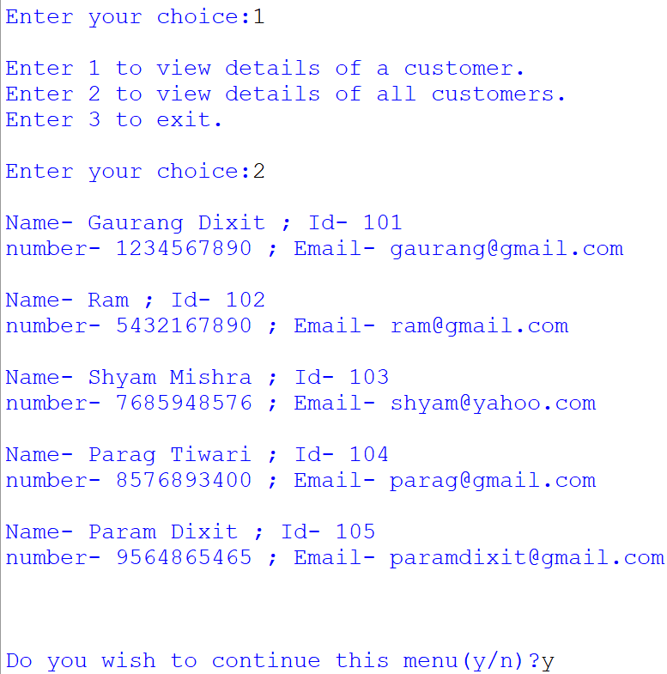

- 2nd option
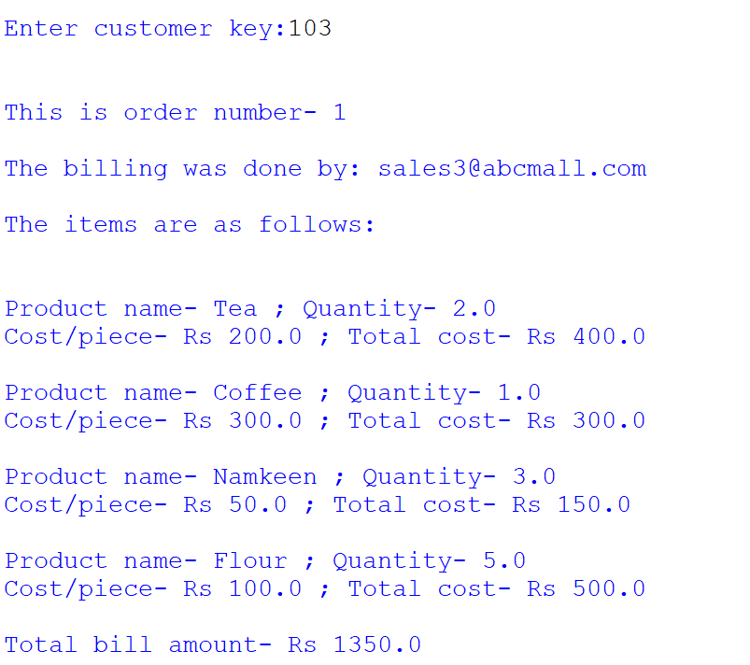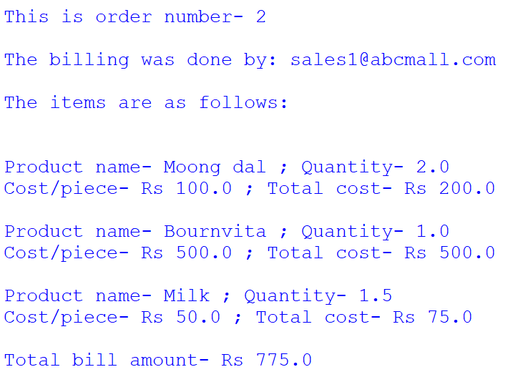

- 4th,5th,6th and 7th option
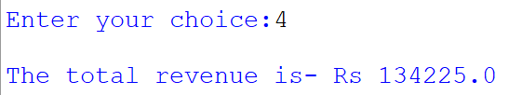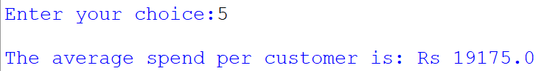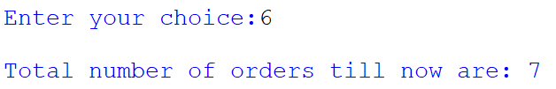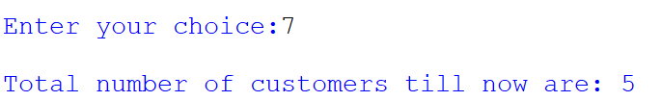

- 8th option
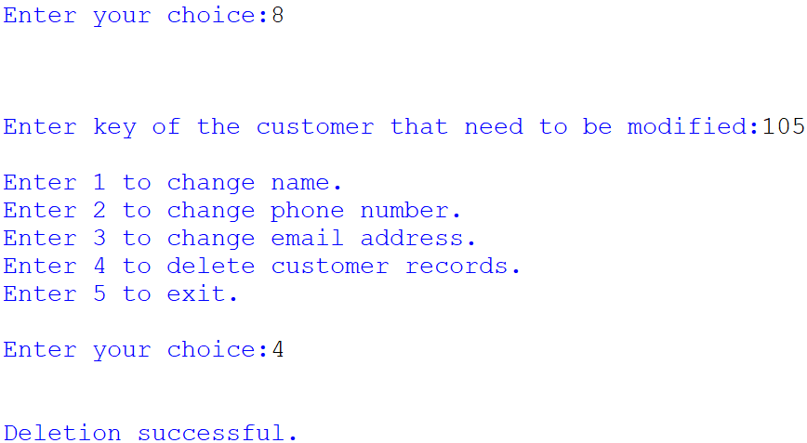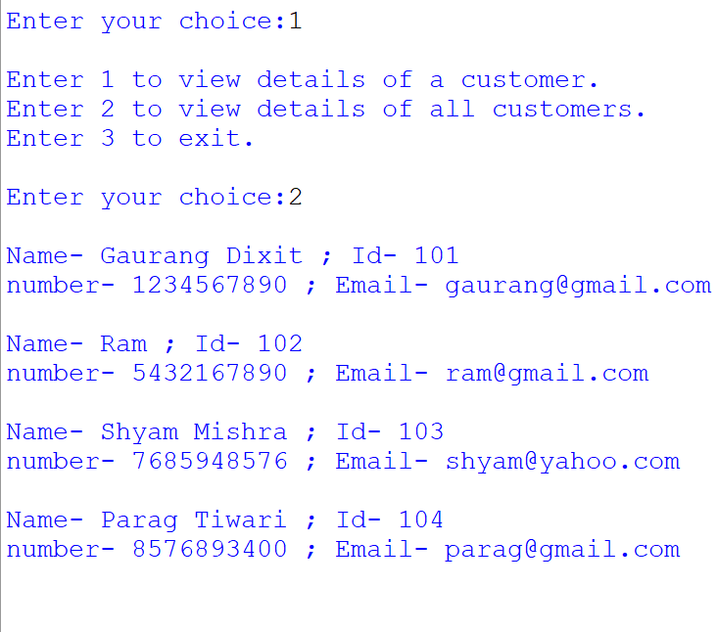

- 9th option
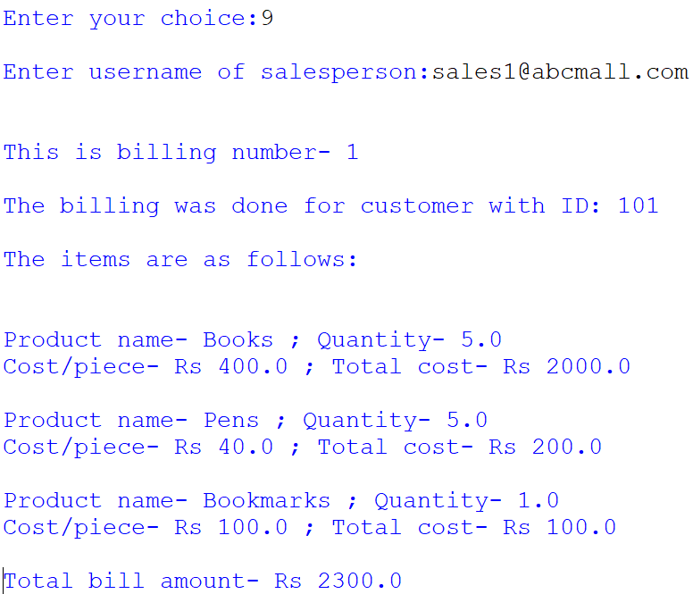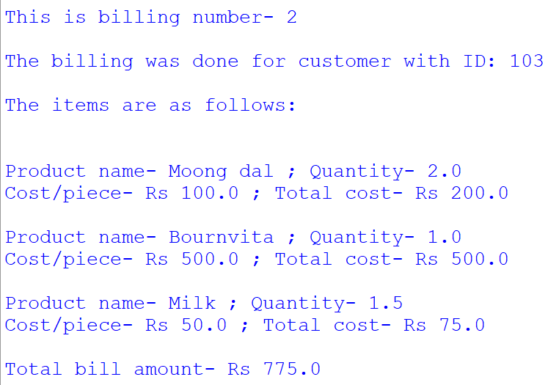

- Program ending
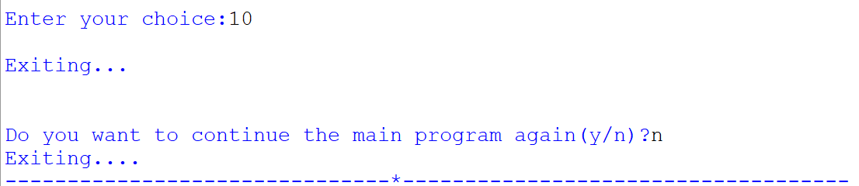

Acknowledgement

I would like to thank my parents for helping me with the printout of my project and for giving me some nice ideas and my teachers for helping me clear my doubts whenever I approached them.

Certificate

